

Course Code : CSE 404

Course Title : Software Engineering and ISD Laboratory

Project name : Bus ticket booking management system

Experiment no: 02

Experiment name: **Requirements Specification Analysis of the project**

**Submitted To**

**Dr. Mohammad Zahidur Rahman**

Professor

**Dr. Md. Humayun Kabir**

Professor

Department of Computer Science & Engineering Jahangirnagar University, Savar.

Group No : 02

Group members :

|  |  |  |
| --- | --- | --- |
| **Sl** | Class Roll | Name |
| 01 | 342 | Tama Shil |
| 02 | 370 | Prokash Maitra |
| 03 | 374 | Mubasher adnan jihad |
| 04 | 375 | Pritam Saha |



Course Code : CSE 404

Course Title : Software Engineering and ISD Laboratory

Project name : Bus ticket booking management system

Experiment no: 02

Experiment name: **Requirements Specification Analysis of the project**

**Submitted To**

**Dr. Mohammad Zahidur Rahman**

Professor

**Dr. Md. Humayun Kabir**

Professor

Department of Computer Science & Engineering Jahangirnagar University, Savar.

Group No : 02

Group members :

|  |  |  |
| --- | --- | --- |
| **Sl** | Class Roll | Name |
| 01 | 342 | Tama Shil |
| 02 | 370 | Prokash Maitra |
| 03 | 374 | Mubasher adnan jihad |
| 04 | 375 | Pritam Saha |

Name : Tama Shil

Id :342

Part: Functions list and DFD

Objective:

The purpose of this document is to provide a comprehensive analysis of the requirements for a Bus Ticket Booking System. This technology intends to promote quick and easy ticket purchasing for customers while optimizing bus company processes. The analysis includes comprehensive reports on each of the system's functional and non-functional requirements.

Functions or services list:

1. Functional requirements
   1. User registration specifications

* User registration authentications specifications
  1. Login specifications
* Login verification specifications
  1. Bus scheduling specifications
  + Add bus schedule
  + Edit bus schedule
  + Delete bus schedule
  + View bus schedule
  1. Reservation specifications
* Reservation specification
* Payment specification
* Cancelation specification

1. Performance specifications
   1. Speed and Latency requirements
   2. Precision and accuracy requirements
2. Dependency Requirements
   1. Reliability requirements
   2. Availability requirements
3. Maintenance and Supportability Requirements
   1. Maintenance Requirements
   2. Supportability Requirements
   3. Security Requirements
   4. Accessibility Requirements

**The Data Flow Diagram (DFD) of the system:**

**Zero Level DFD:**

High level entries and process flow of Bus ticket management system:

* Managing all bus schedules
* Managing all bus reservations
* Managing all bus tickets
* Managing all bus customers
* Managing all bus routes

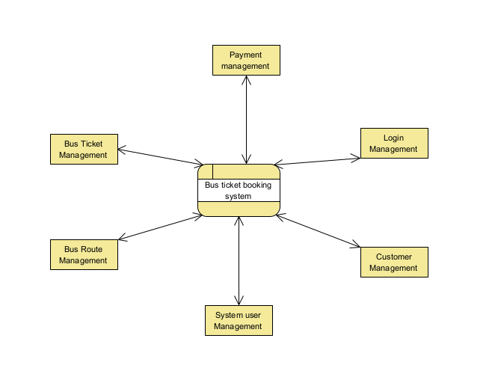

First Level DFD:

Main entries and output of first level DFD:

* Processing bus scheduling and generating reports
* Processing bus records and generating reservations reports
* Processing ticket records and generating reports
* Processing customers records and generating reports
* Processing bus routes records and generating reports
* Processing payment records and generating reports

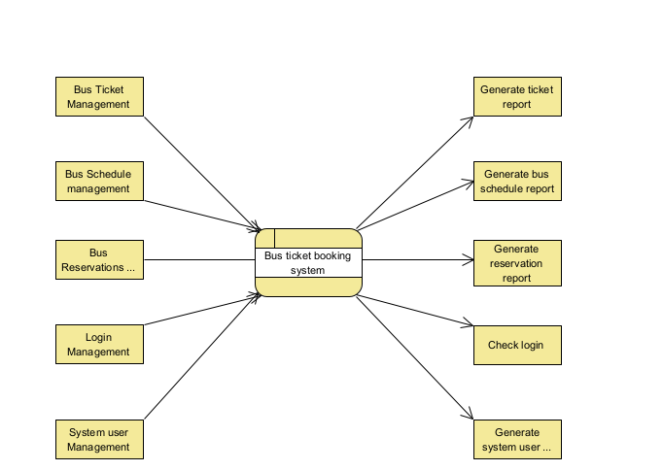

Second Level of DFD (Level 2 DFA):

Low level functionalities of bus ticket booking management system:

* Admin login to the system and manage all functionalities of bus system.
* Admin can add bus route, edit schedules, delete schedules and even view schedules.
* Admin can manage all details about ticket payments, reservation cancellations, booking details, customer details.
* Admin can search the details of booking customers details
* Admin can track detailed information of booking, tickets and customers

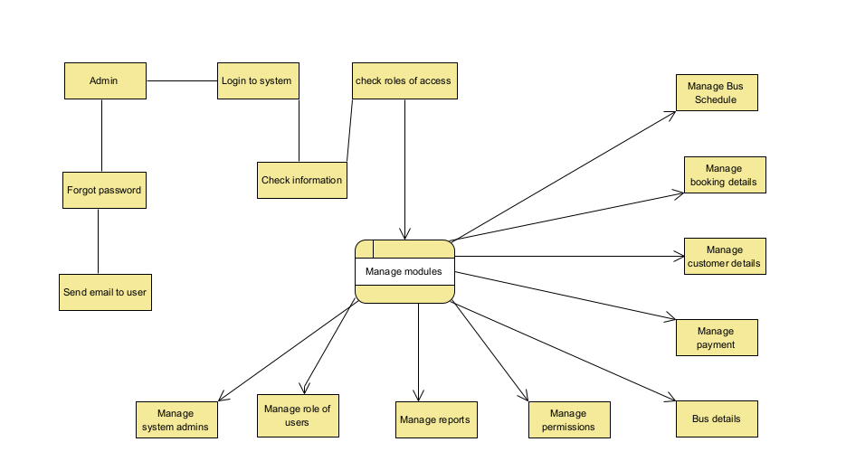

**Pritam Saha**

**Id:375**

**Part: requirements specifications**

1. Functional requirements
   1. User registration specifications

* The user must register to the system
* The user need to fill important information fields like user-id,email,name,phone number gender etc to register
* The user will have to email authentication to confirm the information
  1. Login specifications
* User will insert his username or email and password to login
* The information will be verified
* The user will reenter the information in case of wrong information
  1. Bus scheduling specifications
  + Add bus schedule
* .The system has a function that allow administrator to add the new schedule and the destination to the driver.
* The system will check on the same time, same day and same driver that already have the schedule or not, if yes then the system will not allow the administrator to add the new schedule for the particular driver on the same time, day and place.
* If not then the administrator can assign the new schedule for the particular driver.
  + Edit bus schedule
* The system has a function that allows the administrator to edit the schedule that already assigned.
* If have any happen occur so that the administrator need to reassign the schedule for the driver.
  + Delete bus schedule
* The system has a function that allows the administrator to delete a schedule for the particular driver if they feel that the schedule not suitable for this particular driver on that time
  + View bus schedule
* The system has a function that allow the driver to view the schedule that assign by the administrator according to their name so the driver can know when and what time they should driver the bus from one destination to another destination.
  1. Reservation specifications
* Reservation specification
  + - The system has a function to allow the member to add reservation via online.
    - When the member click the next button then will go to online payment form to make payment.
* Payment specification
  + - When the member click the next button then will go to the online payment form and the member will key in all the information in the payment form then the system will check the credit card no and the credit card expired date whether is valid or not
* Cancelation specification
* The user will be able to cancel the reservation if he wants

**Name**: Prokash Maitra

**Class Roll**: 370

**Exam Roll**: 191372

**Project**: Bus Ticket Managing System

2**. Operation Specification**

2.1 Performance

2.1.1 Speed and Latency Requirements

* + Proper database use
  + Query result reaction

2.1.2 Precision or Accuracy Requirements

* + Effective Login
  + No Signup without Email
  + All input field should insert exact and valid information to the database.

3. **Dependency Requirements**

3.1 Reliability Requirements

* + Only authentic user access to the system
  + New user should login
  + Only admin can manage bus details

3.2 Availability Requirements

* + Available on internet
  + Platform independent
  + Perform quickly on client demand

**Name: Mubasher Adnan Jihad**

**Roll :374**

**Part: Requirement specifications and use case of subsystem 1,2**

1. Maintainability and supportability Requirement
   1. Maintenance Requirements
   * Alter framework applications when they need to change depending on various conditions.
   * Databases are used to maintain information in a systematic way
   * Fixed bugs when the application will be corrupted on crash.
   1. Supportability Requirements

* The user will be provided a user manual with full documentation to make the application more effective.
  1. Security Requirements
* Since the registration process will handle the admin of the company, no one other than the company’s employer can access the system
* Administrator cord will be default accounts which will be usable for investigate the issue and notice the authenticate employees activity
  1. Ease of use Requirements
  + User Interface of the application is user friendly and easy to use for all types of users.
  + The user manual is available for easy access to new users.

4.5 Accessibility Requirement

* This is a web application so it can be accessed from any internet connected device.
* Only after login, the user will be able to access his/her account

**The use case of the system:**

**Subsystem-1**

**Actor:** Customer, Admin.

**Scenario:**

* Customer will Login into system.
* Customer will Register into system.
* Admin will Login into system.

**Exception:** Login page not found.

**Precondition:** Login page from web browser.

**Post condition:**

* Successful Login
* Unsuccessful Login
* Page not found.

**Use case relation:**

1. Include
2. Extends

**Use case Diagram:**

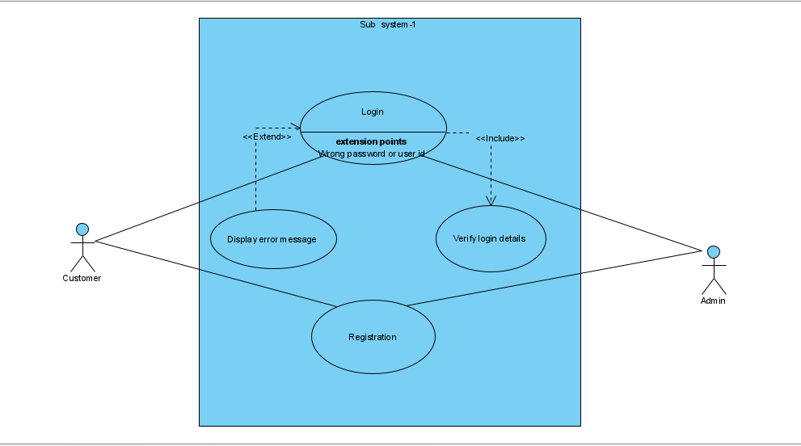

**Subsystem-2**

**Actor:** Customer, Admin.

**Scenario:**

* Customer will do the reservation of buses.
* Both Admin and Customer can send message to each other.
* Customer will do payment.

**Exception:** Wrong customer information.

**Precondition:** Only registered customer can reserve ticket.

**Postcondition:**

* Admin will get a notification about a seat being reserved.
* Customer will get a confirmation notification.

**Use case relation:**

1. Include
2. Extends

**Use case Diagram:**

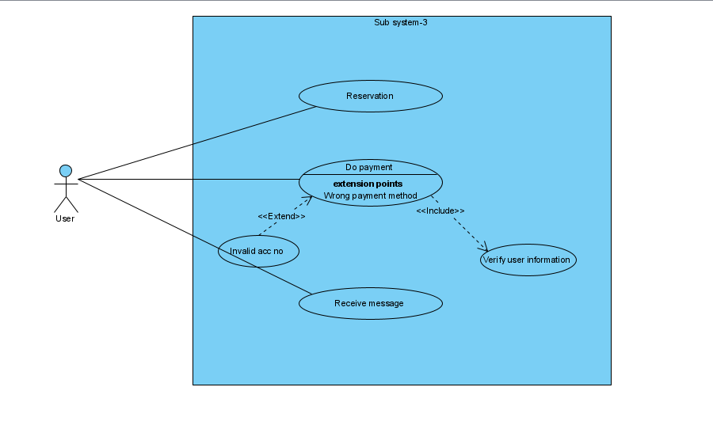

**Pritam Saha**

**Id:375**

**Part: Subsystem-3**

**Actor:** Admin.

**Scenario:**

* Admin will add bus details.
* Admin will input pickup points of all buses so that customer can select pickup points.
* Admin will input bus route and bus name so that these information can be provided to the customer.

**Exception:** Web page not found.

**Precondition:**

* Pickup points must be set according to pick up point and time.
* One time must be provided to one bus at a time.
* Route must be set according to correct route and one bus name must be provided to one bus.

**Postcondition:**

* Admin can provide one pickup time for one bus.
* Admin can provide one bus name and route at a same time.

**Use case relation:**

1. Include relation in pickup point about selecting unique time for one bus at a time.
2. Extend relation for notifying about the collision of bus.

**Use case Diagram:**

